**EXPERIMENT 2: Write JavaScript to validate the following fields of the Registration page**

a) First Name (Name should contains alphabets and the length should not be less than 6 characters).

b) Password (Password should not be less than 6 characters length).

c) E-mail id (should not contain any invalid and must follow the standard pattern [name@domain.com](mailto:name@domain.com))

d) Mobile Number (Phone number should contain 10 digits only). e) Last Name and Address (should not be Empty).

**AIM :**

To create a visually appealing and user-friendly registration form with input validations for fields like first name, last name, email ID, password, and mobile number.

**ALGORITHM :**

• **Create the HTML structure** for the form with fields: First Name, Last Name, Email ID, Password, and Mobile Number.

• **Style the form** with CSS to create an attractive layout, including background colors, form container design, and button styles.

• **Add validation logic** in JavaScript:

* Validate that the First Name contains only alphabets and is at least 6 characters long.
* Ensure the Last Name is not empty.
* Validate that the Email follows the correct pattern (name@domain.com).
* Check that the Password is at least 6 characters long.
* Validate that the Mobile Number contains exactly 10 digits.

• **Display error messages** below each input field if the validation fails.

• **Allow form submission** only if all fields are valid; otherwise, prevent submission and show error messages.

• **Enhance user experience** by applying hover effects on buttons and smooth transitions for form interactions.

**CODE:**

<!DOCTYPE html>

<html lang="en">

<head>

<meta charset="UTF-8">

<meta name="viewport" content="width=device-width, initial-scale=1.0">

<title>Creative Registration Form</title>

<style>

body {

font-family: 'Arial', sans-serif;

background: linear-gradient(to right, #f37cc1, #2575fc); /* Gradient background */

color: #333;

margin: 0;

padding: 0;

display: flex;

justify-content: center;

align-items: center;

height: 100vh;

}

.container {

background-color: #ffffff;

padding: 40px;

border-radius: 10px;

box-shadow: 0 4px 8px rgba(0, 0, 0, 0.1);

width: 400px;

text-align: center;

}

h2 {

color: #007BFF;

margin-bottom: 30px;

}

label {

font-size: 1rem;

margin-bottom: 8px;

display: block;

text-align: left;

color: #555;

}

input[type="text"],

input[type="password"],

input[type="submit"] {

width: 100%;

padding: 12px;

margin: 8px 0 20px 0; /* Added bottom margin to space out fields */

border-radius: 5px;

border: 1px solid #ccc;

font-size: 1rem;

box-sizing: border-box;

}

input[type="submit"] {

background-color: #007BFF;

color: white;

font-size: 1.1rem;

cursor: pointer;

transition: background-color 0.3s ease;

}

input[type="submit"]:hover {

background-color: #e99af3;

}

.error {

color: red;

font-size: 0.9rem;

margin-top: 5px;

text-align: left;

}

.form-group {

margin-bottom: 20px;

}

</style>

</head>

<body>

<div class="container">

<h2>Register Now</h2>

<form id="registrationForm" onsubmit="return validateForm()">

<div class="form-group">

<label for="firstName">First Name:</label>

<input type="text" id="firstName" name="firstName">

<div id="firstNameError" class="error"></div>

</div>

<div class="form-group">

<label for="lastName">Last Name:</label>

<input type="text" id="lastName" name="lastName">

<div id="lastNameError" class="error"></div>

</div>

<div class="form-group">

<label for="email">E-mail:</label>

<input type="text" id="email" name="email">

<div id="emailError" class="error"></div>

</div>

<div class="form-group">

<label for="password">Password:</label>

<input type="password" id="password" name="password">

<div id="passwordError" class="error"></div>

</div>

<div class="form-group">

<label for="mobile">Mobile Number:</label>

<input type="text" id="mobile" name="mobile">

<div id="mobileError" class="error"></div>

</div>

<input type="submit" value="Submit">

</form>

</div>

<script>

function validateForm() {

// Clear any previous errors

const errorElements = document.querySelectorAll('.error');

errorElements.forEach(error => error.textContent = '');

// Validate First Name

const firstName = document.getElementById('firstName').value;

const firstNamePattern = /^[A-Za-z]+$/;

if (firstName.length < 6 || !firstNamePattern.test(firstName)) {

document.getElementById('firstNameError').textContent = 'First Name should contain only alphabets and be at least 6 characters long.';

return false;

}

// Validate Last Name

const lastName = document.getElementById('lastName').value;

if (lastName.trim() === "") {

document.getElementById('lastNameError').textContent = 'Last Name should not be empty.';

return false;

}

// Validate E-mail

const email = document.getElementById('email').value;

const emailPattern = /^[a-zA-Z0-9._%+-]+@[a-zA-Z0-9.-]+\.[a-zA-Z]{2,}$/;

if (!emailPattern.test(email)) {

document.getElementById('emailError').textContent = 'Please enter a valid email address (name@domain.com).';

return false;

}

// Validate Password

const password = document.getElementById('password').value;

if (password.length < 6) {

document.getElementById('passwordError').textContent = 'Password should be at least 6 characters long.';

return false;

}

// Validate Mobile Number

const mobile = document.getElementById('mobile').value;

const mobilePattern = /^\d{10}$/;

if (!mobilePattern.test(mobile)) {

document.getElementById('mobileError').textContent = 'Mobile number must contain exactly 10 digits.';

return false;

}

// If all validations pass, allow form submission

return true;

}

</script>

</body>

</html>

**OUTPUT:**

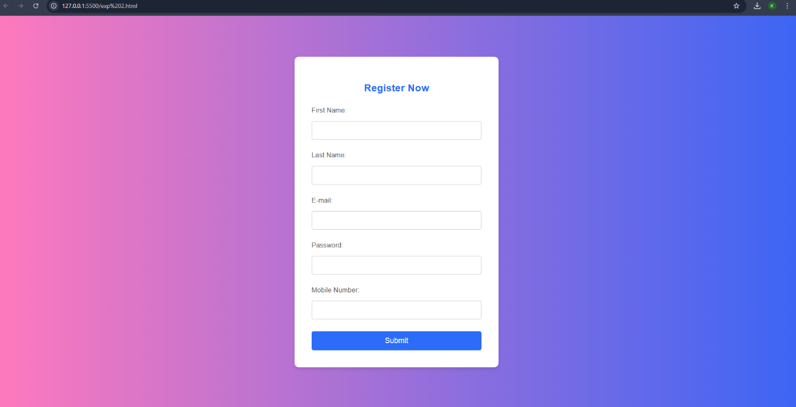

**RESULT :**

Thus the give task is executed successfully.

b) Create a web page using an embedded, external and inline CSS file.

**AIM:**

Demonstrate the use of inline, embedded, and external CSS to style a webpage with a clean and professional design.

**ALGORITHM:**

• Define the basic HTML structure with header, main content, and footer sections.

• Style the webpage with embedded CSS to design a clean, responsive layout.

• Divide the main content into three distinct sections: Web Development, Creative Design, and SEO Optimization.

• Add hover effects to the sections to enhance interactivity.

• Include relevant content for each section describing the services provided.

• Provide call-to-action buttons ("Learn More", "Explore Our Designs", "Boost Your Ranking") for user engagement.

• Add a footer with copyright information and a message.

• Test the webpage for responsiveness and interactivity across devices.

**CODE :**

<!DOCTYPE html>

<html lang="en">

<head>

<meta charset="UTF-8">

<meta name="viewport" content="width=device-width, initial-scale=1.0">

<title>Creative Web Design</title>

<style>

/* Embedded CSS */

body {

font-family: 'Arial', sans-serif;

margin: 0;

padding: 0;

background-color: #fafafa;

}

header {

background-color: #333;

color: white;

padding: 20px;

text-align: center;

}

/* External CSS can be linked as well - for demonstration, we'll include it inline */

.main-content {

display: flex;

justify-content: space-between;

margin: 20px;

gap: 20px;

}

.section {

background-color: #fff;

padding: 20px;

width: 30%;

box-shadow: 0 0 10px rgba(0, 0, 0, 0.1);

transition: transform 0.3s;

border-radius: 8px;

}

.section:hover {

transform: translateY(-10px);

}

.section h3 {

color: #333;

margin-bottom: 15px;

font-size: 1.5rem;

}

.section p {

font-size: 1rem;

color: #666;

margin-bottom: 20px;

}

.btn {

background-color: #007BFF;

color: white;

padding: 10px;

text-decoration: none;

border-radius: 5px;

display: inline-block;

}

.btn:hover {

background-color: #0056b3;

}

footer {

text-align: center;

padding: 20px;

background-color: #333;

color: white;

margin-top: 30px;

font-size: 1rem;

}

</style>

<link rel="stylesheet" href="styles.css"> <!-- External CSS file, assuming "styles.css" is available -->

</head>

<body>

<header>

<h1>Creative Web Design</h1>

<p>Discover cutting-edge web solutions that blend creativity and functionality.</p>

</header>

<div class="main-content">

<div class="section">

<h3>Web Development</h3>

<p>Our web development services are designed to help you build highly functional websites tailored to your business needs. We specialize in responsive design, seamless user experience, and fast-loading pages that drive engagement.</p>

<a href="#" class="btn">Learn More</a>

</div>

<div class="section" style="background-color: #f9f9f9;"> <!-- Inline CSS for this section -->

<h3>Creative Design</h3>

<p>Stand out with visually stunning and user-friendly designs. We combine aesthetics and purpose to create websites that captivate visitors and represent your brand identity effectively. From custom graphics to intuitive layouts, we ensure your website is both beautiful and functional.</p>

<a href="#" class="btn">Explore Our Designs</a>

</div>

<div class="section">

<h3>SEO Optimization</h3>

<p>Boost your website’s visibility with our comprehensive SEO optimization services. We help you improve your search engine rankings, driving organic traffic and enhancing your digital presence. Our strategies focus on both on-page and off-page SEO techniques to ensure long-term success.</p>

<a href="#" class="btn">Boost Your Ranking</a>

</div>

</div>

<footer>

<p>&copy; 2025 Creative Website. All rights reserved. | Designed with passion by the Creative Team</p>

</footer>

</body>

</html>

**OUTPUT:**

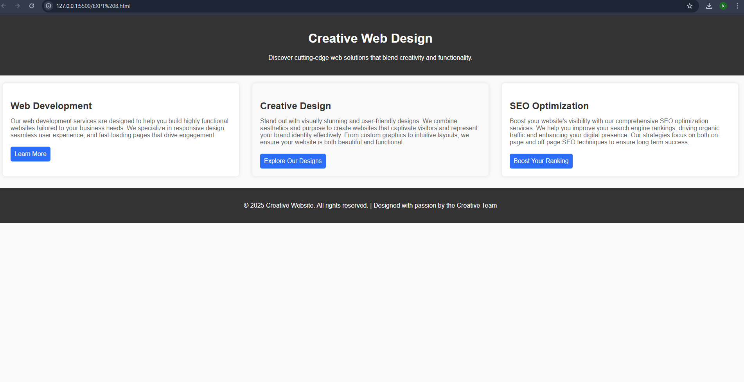

**RESULT:**

Thus the given task is executed successfully.